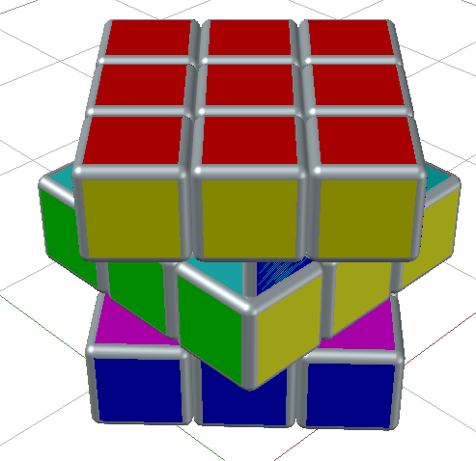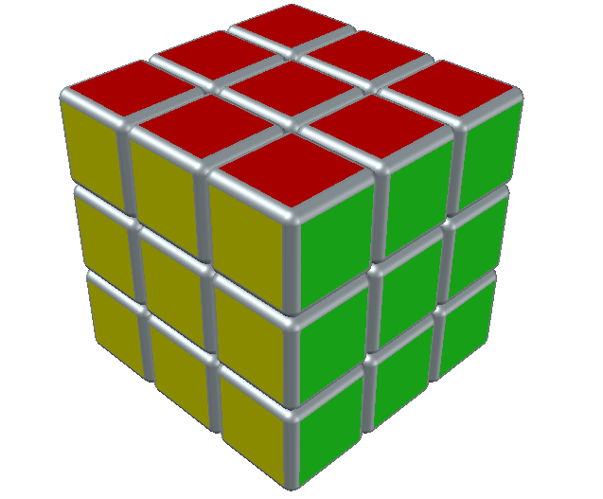Task 1 :

***Commands :***

|  |  |
| --- | --- |
| Opening an AutoCAD 2018 format file.  AutoCAD menu utilities loaded.  AutoCAD Electrical menu utilities loaded.*Cancel*  Command:  Autodesk DWG. This file is a TrustedDWG last saved by an Autodesk application or Autodesk licensed application.  Command: _.erase 1 found  Command: *Cancel*  Command: _qsave  Command: _rectang  Specify first corner point or [Chamfer/Elevation/Fillet/Thickness/Width]:  Resuming RECTANG command.  Specify first corner point or [Chamfer/Elevation/Fillet/Thickness/Width]:  Specify other corner point or [Area/Dimensions/Rotation]: d  Specify length for rectangles <10.0000>: 5  Specify width for rectangles <10.0000>: 5  Specify other corner point or [Area/Dimensions/Rotation]:  Point or option keyword required.  Specify other corner point or [Area/Dimensions/Rotation]:  Command: EXT  EXTRUDE  Select an edge or [Chain/Loop/Radius]:  Select an edge or [Chain/Loop/Radius]:  Resuming FILLETEDGE command.  Select an edge or [Chain/Loop/Radius]:  Select an edge or [Chain/Loop/Radius]:  Resuming FILLETEDGE command.  Select an edge or [Chain/Loop/Radius]:  Resuming FILLETEDGE command.  Select an edge or [Chain/Loop/Radius]:  Resuming FILLETEDGE command.  Enter fillet radius or [Expression] <0.5000>: 0.5  Select an edge or [Chain/Loop/Radius]:  12 edge(s) selected for fillet.  Press Enter to accept the fillet or [Radius]:  Command: *Cancel*  Command: EXPLODE  Select objects: Specify opposite corner: 1 found  Select objects:  Command: *Cancel*  Command: *Cancel*  Command: UNION  Select objects: Specify opposite corner: 26 found  Select objects:  Command: *Cancel*  Command: ARRAY  Select objects: Specify opposite corner: 7 found  Select objects:  Enter array type [Rectangular/PAth/POlar] <Rectangular>:  Type = Rectangular Associative = Yes  Select grip to edit array or [ASsociative/Base point/COUnt/Spacing/COLumns/Rows/Levels/eXit]<eXit>:  Select grip to edit array or [ASsociative/Base point/COUnt/Spacing/COLumns/Rows/Levels/eXit]<eXit>:  Select grip to edit array or [ASsociative/Base point/COUnt/Spacing/COLumns/Rows/Levels/eXit]<eXit>:  Select grip to edit array or [ASsociative/Base point/COUnt/Spacing/COLumns/Rows/Levels/eXit]<eXit>:  Select grip to edit array or [ASsociative/Base point/COUnt/Spacing/COLumns/Rows/Levels/eXit]<eXit>:  Select grip to edit array or [ASsociative/Base point/COUnt/Spacing/COLumns/Rows/Levels/eXit]<eXit>:  Command:  Command:  Command: _qsave | Current wire frame density: ISOLINES=4, Closed profiles creation mode = Solid  Select objects to extrude or [MOde]: 1 found  Select objects to extrude or [MOde]:  Specify height of extrusion or [Direction/Path/Taper angle/Expression] <5.0000>: 5  Command:  Command: FILLETEDGE  Radius = 0.5000  Select an edge or [Chain/Loop/Radius]:  Select an edge or [Chain/Loop/Radius]:  Select an edge or [Chain/Loop/Radius]:  Select an edge or [Chain/Loop/Radius]:  Select an edge or [Chain/Loop/Radius]:  Select an edge or [Chain/Loop/Radius]:  Select an edge or [Chain/Loop/Radius]:  Select an edge or [Chain/Loop/Radius]:  Select an edge or [Chain/Loop/Radius]:  Resuming FILLETEDGE command.  Select an edge or [Chain/Loop/Radius]:  Resuming FILLETEDGE command.  Select an edge or [Chain/Loop/Radius]:  Select an edge or [Chain/Loop/Radius]:  Select an edge or [Chain/Loop/Radius]:  Select an edge or [Chain/Loop/Radius]:  Resuming FILLETEDGE command.  Select an edge or [Chain/Loop/Radius]:  Resuming FILLETEDGE command.  Select an edge or [Chain/Loop/Radius]:  Resuming FILLETEDGE command.  Select an edge or [Chain/Loop/Radius]: r  Command:  Command: |

***Task 2 :***

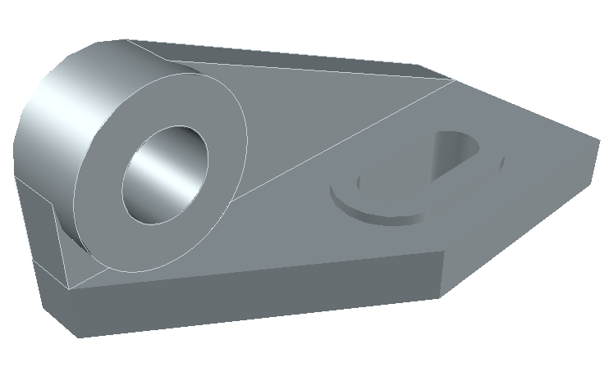

***Commands :***

|  |  |
| --- | --- |
| Select source object or multiple objects to join at once: Specify opposite corner: 5 found  Select objects to join:  4 objects joined into 1 spline, 1 object discarded from the operation  Command:  Press ESC or ENTER to exit, or right-click to display shortcut-menu.  Command:  Command: *Cancel*  Command: *Cancel*  Command:  Command:  Command:  Command: _copyclip 1 found  Command:  Command:  Command: _pasteclip Specify insertion point:  Command:  Press ESC or ENTER to exit, or right-click to display shortcut-menu.  Command:  Command: Specify opposite corner or [Fence/WPolygon/CPolygon]:  Command: m  MOVE 1 found  Specify base point or [Displacement] <Displacement>:  Specify second point or <use first point as displacement>:  Command: *Cancel*  Command:  Press ESC or ENTER to exit, or right-click to display shortcut-menu.  Command: _u '3DORBIT GROUP  Command: _u MOVE  Command:  Command: *Cancel*  Command:  Command: *Cancel*  Command: m  MOVE  Select objects: 1 found  Select objects:  Specify base point or [Displacement] <Displacement>: *Cancel*  Command: *Cancel*  Command: m  MOVE  Select objects: 1 found  Select objects:  Specify base point or [Displacement] <Displacement>:  Specify second point or <use first point as displacement>:  Command:  Press ESC or ENTER to exit, or right-click to display shortcut-menu.  Command:  Command:  Command: *Cancel*  Command:  Command:  ** STRETCH **  Command: *Cancel*  Command: '3DORBIT  Press ESC or ENTER to exit, or right-click to display shortcut-menu.  Command: SUBTRACT  Select solids, surfaces, and regions to subtract from ..  Select objects: 1 found  Select objects:  Select solids, surfaces, and regions to subtract ..  Select objects: *Cancel*  Command: _u SUBTRACT  Command: _u '3DORBIT  Command: _u '3DORBIT GROUP  Command: _u SUBTRACT  Command:  Press ESC or ENTER to exit, or right-click to display shortcut-menu.  Command: SUBTRACT  Select solids, surfaces, and regions to subtract from ..  Select objects: 1 found  Select objects:  Select solids, surfaces, and regions to subtract ..  Select objects: 1 found  Select objects:  Command: *Cancel*  Command:  Press ESC or ENTER to exit, or right-click to display shortcut-menu.  Command:  Command:  Press ESC or ENTER to exit, or right-click to display shortcut-menu.  Command: Specify opposite corner or [Fence/WPolygon/CPolygon]: *Cancel*  Command: *Cancel*  Command:  Press ESC or ENTER to exit, or right-click to display shortcut-menu.  Command:  Command:  Press ESC or ENTER to exit, or right-click to display shortcut-menu.  Command: *Cancel*  Command: Specify corner of window, enter a scale factor (nX or nXP), or [All/Extents/Window/Previous/Object] <real time>:  Command: _u 'ZOOM GROUP  Command: _u '3DORBIT GROUP  Command: _u '3DORBIT GROUP  Command: _u '3DORBIT GROUP  Command: _u EXPLODE  Command: _u '3DORBIT GROUP  x  Select cross sections in lofting order or [POint/Join multiple edges/MOde]: Specify opposite corner:  Selected profile cannot be a multi-face surface or region.  The selected entities are not valid.  Selected cross section is not a valid type.  Selected profile cannot be a multi-face surface or region.  The selected entities are not valid.  Cross-section curves must be all open or all closed.  Cross-section curves must be all open or all closed.  Cross-section curves must be all open or all closed.  Cannot create a solid from open cross sections.  Cross-section curves must be all open or all closed.  Cannot create a solid from open cross sections.16 found  7 were filtered out  Select cross sections in lofting order or [POint/Join multiple edges/MOde]:  9 cross sections selected  Enter an option [Guides/Path/Cross sections only/Settings/COntinuity/Bulge magnitude] <Cross sections only>:  The selected entities are not valid.  Command:  LOFT  Current wire frame density: ISOLINES=4, Closed profiles creation mode = Solid  Select cross sections in lofting order or [POint/Join multiple edges/MOde]:  At least two profiles must be selected.  Command:  LOFT  Current wire frame density: ISOLINES=4, Closed profiles creation mode = Solid  Select cross sections in lofting order or [POint/Join multiple edges/MOde]:  At least two profiles must be selected.  At least two profiles must be selected.  Command: *Cancel*  Command: Specify opposite corner or [Fence/WPolygon/CPolygon]:  Command: JOIN  16 found  0 objects joined, 15 objects discarded from the operation  Command:  Press ESC or ENTER to exit, or right-click to display shortcut-menu.  Command: Specify corner of window, enter a scale factor (nX or nXP), or [All/Extents/Window/Previous/Object] <real time>:  Command:  Command: Specify opposite corner or [Fence/WPolygon/CPolygon]: *Cancel*  Command: *Cancel*  Command:  Press ESC or ENTER to exit, or right-click to display shortcut-menu. | Specify stretch point or [Base point/Copy/Undo/eXit]:*Cancel*  Command: *Cancel*  Command:  Press ESC or ENTER to exit, or right-click to display shortcut-menu.  Command: *Cancel*  Command:  Command: _.erase 1 found  Command: *Cancel*  Command:  Command: *Cancel*  Command:  Command: EXT  EXTRUDE  Current wire frame density: ISOLINES=4, Closed profiles creation mode = Solid  1 found  Specify height of extrusion or [Direction/Path/Taper angle/Expression] <16.0000>: 16  Command:  Press ESC or ENTER to exit, or right-click to display shortcut-menu.  Command:  Command: EXTRUDE  Current wire frame density: ISOLINES=4, Closed profiles creation mode = Solid  1 found  Specify height of extrusion or [Direction/Path/Taper angle/Expression] <16.0000>:  Command: *Cancel*  Command: _u EXTRUDE  Command:  Command: EXT  EXTRUDE  Current wire frame density: ISOLINES=4, Closed profiles creation mode = Solid  1 found  Specify height of extrusion or [Direction/Path/Taper angle/Expression] <19.0000>: 22  Command:  Press ESC or ENTER to exit, or right-click to display shortcut-menu.  Command: SUBTRACT  Select solids, surfaces, and regions to subtract from ..  Select objects: 1 found  Select objects:  Select solids, surfaces, and regions to subtract ..  Select objects: 1 found  Select objects:  Command:  Press ESC or ENTER to exit, or right-click to display shortcut-menu.  Command:  Specify stretch point or [Base point/Copy/Undo/eXit]:*Cancel*  Command: *Cancel*  Command:  Press ESC or ENTER to exit, or right-click to display shortcut-menu.  Command: *Cancel*  Command:  Command: _.erase 1 found  Command: *Cancel*  Command:  Command: *Cancel*  Command:  Command: EXT  EXTRUDE  Current wire frame density: ISOLINES=4, Closed profiles creation mode = Solid  1 found  Specify height of extrusion or [Direction/Path/Taper angle/Expression] <16.0000>: 16  Command:  Press ESC or ENTER to exit, or right-click to display shortcut-menu.  Command:  Command: EXTRUDE  Current wire frame density: ISOLINES=4, Closed profiles creation mode = Solid  1 found  Specify height of extrusion or [Direction/Path/Taper angle/Expression] <16.0000>:  Command: *Cancel*  Command: _u EXTRUDE  Command:  Command: EXT  EXTRUDE  Current wire frame density: ISOLINES=4, Closed profiles creation mode = Solid  1 found  Specify height of extrusion or [Direction/Path/Taper angle/Expression] <19.0000>: 22  Command:  Press ESC or ENTER to exit, or right-click to display shortcut-menu.  Command: SUBTRACT  Select solids, surfaces, and regions to subtract from ..  Select objects: 1 found  Select objects:  Select solids, surfaces, and regions to subtract ..  Select objects: 1 found  Select objects:  Command:  Press ESC or ENTER to exit, or right-click to display shortcut-menu.  Command:  Command: _u '3DORBIT GROUP  Command: _u SUBTRACT  Command: *Cancel*  Command:  Press ESC or ENTER to exit, or right-click to display shortcut-menu.  Command:  Command: *Cancel*  Command:  Command: EXPLODE  1 found  Command:  Command: _.erase 1 found  Command: _u ERASE  Command: *Cancel*  Command: *Cancel*  Command: <Switching to: Layout1>  Regenerating layout.  Command: Specify opposite corner or [Fence/WPolygon/CPolygon]: *Cancel*  Command: _.MSPACE  Command: Specify corner of window, enter a scale factor (nX or nXP), or [All/Extents/Window/Previous/Object] <real time>:  Command:  Command:  Command: _.PSPACE  Command: Specify opposite corner or [Fence/WPolygon/CPolygon]: *Cancel*  Command: _.MSPACE  Command:  Command: _.PSPACE  Command: Specify opposite corner or [Fence/WPolygon/CPolygon]:  Command: Specify opposite corner or [Fence/WPolygon/CPolygon]: *Cancel*  Command: _.MSPACE  Command: <Grid off>  Command:  Command:  Command: _PLOT Effective plotting area: 210.00 wide by 297.00 high  Effective plotting area: 155.96 wide by 205.53 high  Plotting viewport 1.  Command: _.PSPACE  Command:  Press ESC or ENTER to exit, or right-click to display shortcut menu.  Command: Specify opposite corner or [Fence/WPolygon/CPolygon]: *Cancel*  Command: _.MSPACE  Command:  Command: _.PSPACE  Command:  Command:  Command: _qsave |